Top left box: day planner
Bottom left box: filter/adjusted
Right box: Event selection interface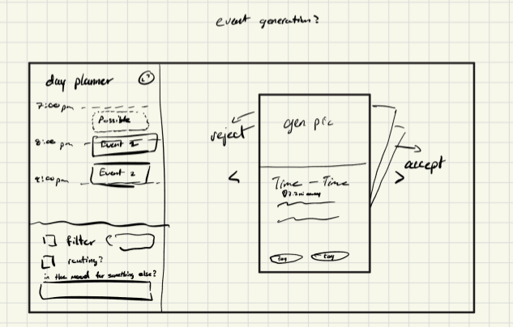
(This picture represents what our web/UI will be looking like more or less, try to analyze the picture to understand how it should look like. You will later write very detailed descriptions of the UI for this project/Front End)

This will use HTML/CSS, and JavaScript. For this project, Atlas, our interface is going to be slightly inspired by tinder. About 2/3rds of the right side is going to be curated/generated events: curated events are events that are scraped from the university website, discords, emails, etc. A popup will appear with two buttons on the left and right side; reject and accept respectively. The buttons can look like < and > for now. As for the popup itself, the top third will be an AI generated picture of the event, made by as much knowledge as the AI can get from the event description. Right below that is the starting and ending time estimate, and below that will be the user’s distance from the event. The event curator will try its best to prioritize events that are close by and in an open time frame on the user’s day planner.
The top left box of the screen will be a calendar-style day planner with hourly increments (there will still be dotted lines in between to separate by the half hour, from up to down) something like apple calendar, and text boxes that can be filled up to the right of them. These boxes will entirely be dependent on whether the user clicks “accept” or “reject” on the displayed event. In the top right corner of this day planner box will be a “fullscreen” button to show a better-formatted day planner, and pressing escape should allow the user to go back to the normal display. Whenever a user clicks accept or deny, AI will make sure to learn what types of events that the user likes based on their preferences. The bottom left box will be for filtering purposes. The first button is “filter” with a mini searchbar, which is good for searching for specific “tags” that an event may contain (i.e. engineering, party, beach, music). The next button is “routing,” which is meant to add a quick map pop-up that can route the user from their current location to the location of the currently-displayed event. When this pop-up is active, all other buttons should be disabled, and clicking anywhere other than the pop-up will make it disappear and enable all other buttons again. Lastly is a small chat bar at the bottom of the bottom-left box, in which the user can speak to an AI to manually update preferences. It’s not a filter or anything, as the user can either speak in full sentences or just provide a few words. Its a mood selector to tell the preference selector what they want in the short term, independent of user preferences.
Next is event generation, which is incorporated into the event curation. While real, organized school events/parties are popping up throughout event curation, event generation will wedge customized, tailored, unofficial events into the event selection interface. Examples of this would be “take a quick nap,” or “perhaps get some studying done?” or “there’s a cool hiking spot you haven’t tried yet.” Of course, preferences will be learned depending on what the user accepts and rejects, but it’s still nice to suggest things like naps and studying every now and then. These events will be mixed with other events happening in the area. Eventually when all local events dry up, replace the event curator with a “no more events found” message.

